Condition Loops

Look at this code:
target = 7
attempts = 0
guess = 0
while guess != target and attempts < 3:
guess = int(input("Guess 1 to 10: "))
attempts = attempts + 1
print("Finished in", attempts, "tries.")

What do you think this code will do for guesses 5 and 7?
Click or tap here to enter text.

Run the code. Compare the result with your prediction:
Click or tap here to enter text.

Let’s investigate! Answer the questions below:
- Which two stored values change each time the loop runs?
Click or tap here to enter text.

- Why does the terminating guess still increase the attempt counter?
Click or tap here to enter text.

- If the guesses are 2 and then 7, what does the final line display?
Click or tap here to enter text.

- Why does the loop stop after three wrong guesses even though the target was not found?
Click or tap here to enter text.

Condition Loops

Look at this code:
target = 7
attempts = 0
guess = 0
while guess != target and attempts < 3:
guess = int(input("Guess 1 to 10: "))
attempts = attempts + 1
print("Finished in", attempts, "tries.")

Use the code above to help you. After completing each challenge below, run your program to test that it works correctly. Save each completed challenge program in a new file.

Programming Challenges

Challenge 1
Change the example so the final message explains why the loop stopped. After the loop, use an if statement to display "Correct!" when guess equals target ; otherwise display "Out of guesses. It was 7." Test 7, then test 1, 2 and 3.
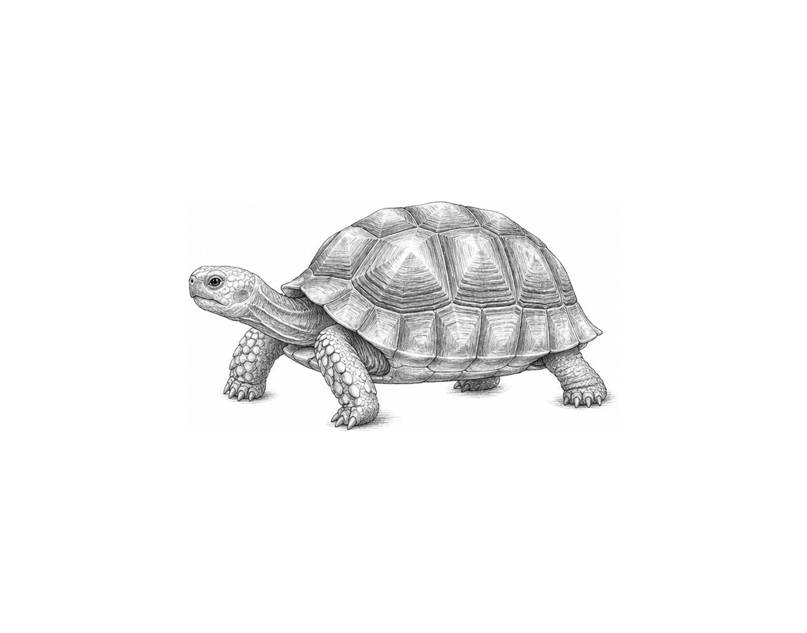

Challenge 2
Extend the example so each wrong guess gets a hint. Inside the while loop, use if and elif to display "Too low" or "Too high" after each guess that is not 7. For example, 5, 9 and 7 display "Too low", then "Too high".

Challenge 3
Create a door-code checker. Store "open" in password . Use a while loop to ask for a code until it is correct or three attempts are used. Display "Door opened." or "Door locked." followed by the attempts used. For example, "red", "blue" and "green" display "Door locked. Attempts used: 3".

Condition Loops

Fix the code!

This code has errors! Look closely at the code to find the problems:

target = 7
attempts = 0
guess = 0
while guess != target and attempts < 3:
guess = int(input("Guess 1 to 10: "))
attempts = attempts + "1"
print("Finished in", attempts, "tries.")

Rewrite the whole program in the box below with fixes to the errors.
Click or tap here to enter text.

After you are confident that you fixed all the errors, copy the code from the box and run it.

Did it work correctly on your first try? Did you find all the errors?
Click or tap here to enter text.

